Restricting and sorting data

- Display the ENAME, SAL, COMM from the EMP table who earn commission and sort the records in descending order of Salary and Commission. Use column's numeric position in the ORDER BY clause.

select ename,sal,comm from emp where comm is not null order by 2 desc,3 desc;

Output:-

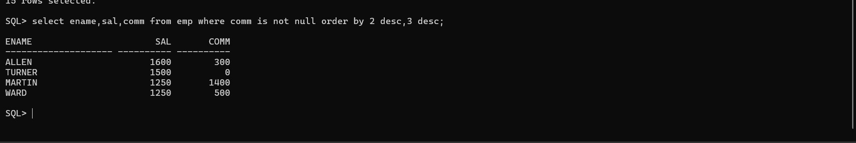

- The HR department needs a query to display all unique job codes from the EMP table.

select distinct(job) from EMP;

Output:-

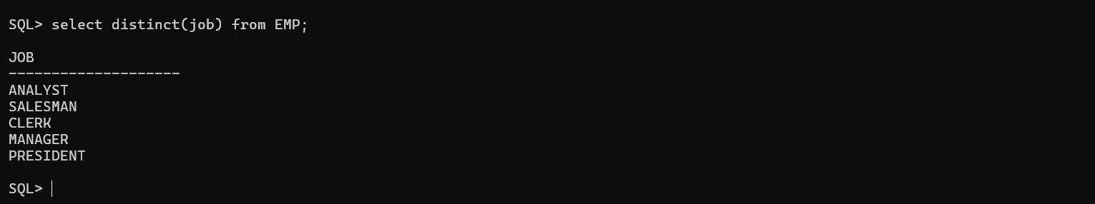

- The HR department wants more descriptive column headings for its report on employees. Name the column headings Emp #, Employee, Job, and Hire Date, respectively, by giving Column Alias.

select EMPNO AS "EMP #",ENAME AS EMPLOYEE_NAME,JOB AS Job,MGR AS MANAGER,HIREDATE AS "HIRE DATE",SAL AS SALARY,COMM AS COMMISSION,DEPTNO AS DEPT_NO from emp;

Output:-



- The HR department has requested a report of all employees and their job IDs. Display the last name concatenated with the job ID (separated by a comma and a space) and name the column Employee and Title by giving Column Alias.

SELECT ename || ', ' || job AS "Employee and Title" FROM emp;

Output:-

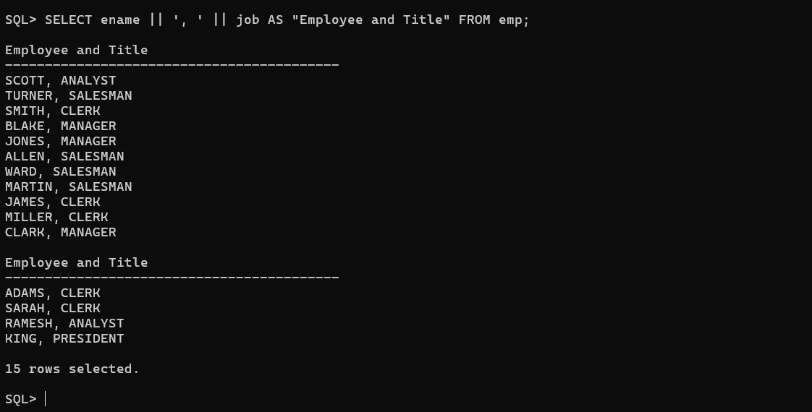

- To familiarize yourself with the data in the EMP table, create a query to display all the data from that table. Separate each column output by a comma. ENAME, JOB, HIREDATE, MGR. Name the column title THE_OUTPUT.

SELECT empno || ', ' || ename || ', ' || job || ', ' || mgr || ', ' || hiredate || ', ' || sal || ', ' || comm || ', ' || deptno AS "THE_OUTPUT" FROM emp;

Output:-

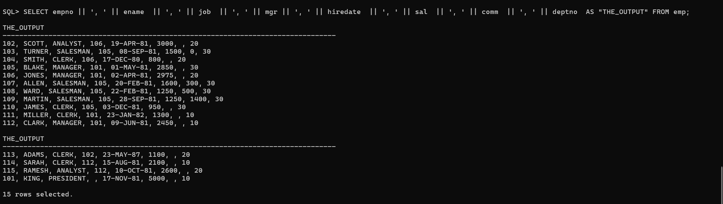

- Create a report to display the ENAME, JOB, and HIREDATE for the employees whose name is SCOTT or TURNER. Order the query in ascending order by HIREDATE.

SELECT ENAME, JOB, HIREDATE
FROM EMP
WHERE ENAME IN ('SCOTT', 'TURNER')
ORDER BY HIREDATE ASC;

Output:-

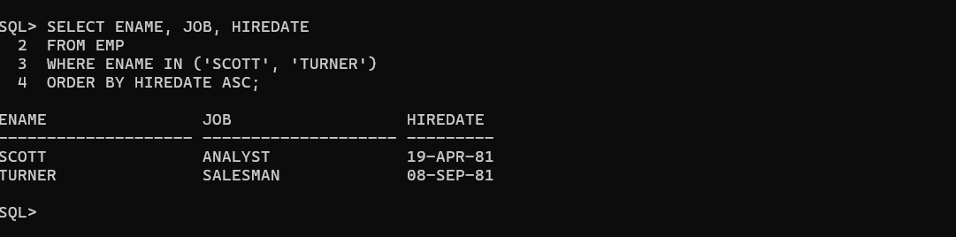

- Display the ENAME and DEPTNO of all employees in departments 20 or 30 in ascending alphabetical order by ENAME.

SELECT ENAME, DEPTNO
FROM EMP
WHERE DEPTNO IN (20, 30)
ORDER BY ENAME ASC;

Output:-

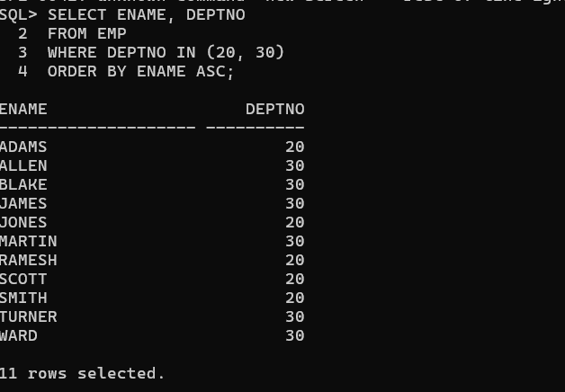

- Modify the previous query to display the last name and salary of employees who earn between 2000 and 3000 and are in department 20 or 30. Label the columns Employee and Monthly Salary, respectively, by giving Column Alias.

select ename as Employee,sal as Monthly_salary from emp
where deptno in(20,30) and sal between 2000 and 3000;

Output:-

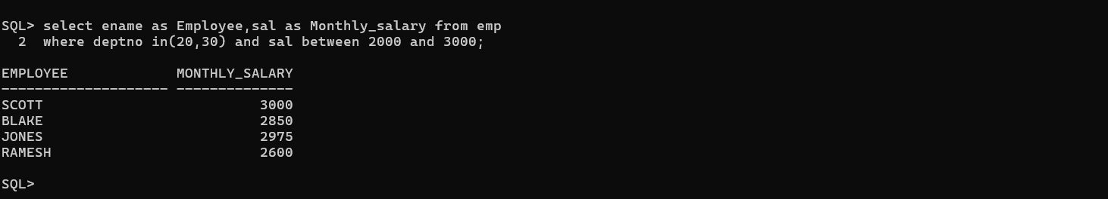

- The HR department needs a report that displays the last name and hire date for all employees who were hired in 1981.

SELECT ENAME, HIREDATE
FROM EMP
WHERE EXTRACT(YEAR FROM HIREDATE) = 1981;

Output:-

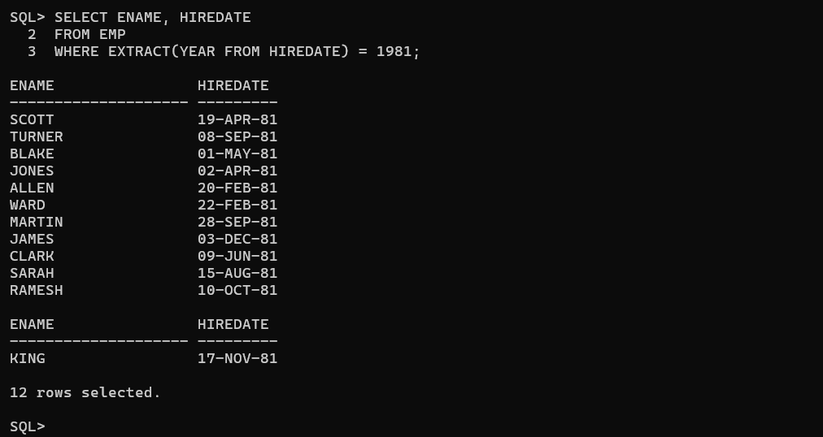

- Display the ENAME and SAL of employees who earn more than an amount the user specifies after a prompt.

select ename,sal from emp where sal>&sal;

Output:-

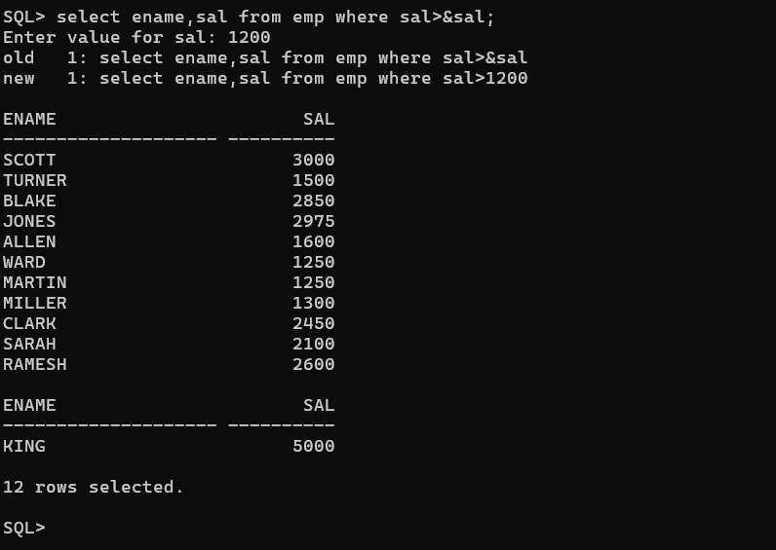

- Create a report to display the last name and job title of all employees who do not have a manager.

select ename,job from emp where mgr is null;

Output:-

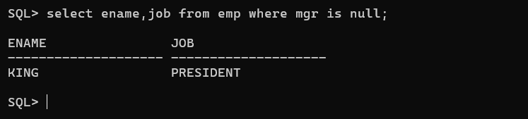

- Create a query that prompts the user for Manager ID and generates EMPNO, ENAME, SAL, DEPTNO. The user should have the ability to sort the records on a selected column.

SELECT EMPNO, ENAME, SAL, DEPTNO
FROM EMP
WHERE MGR = &MGR
ORDER BY &COLUMN;

Output:-

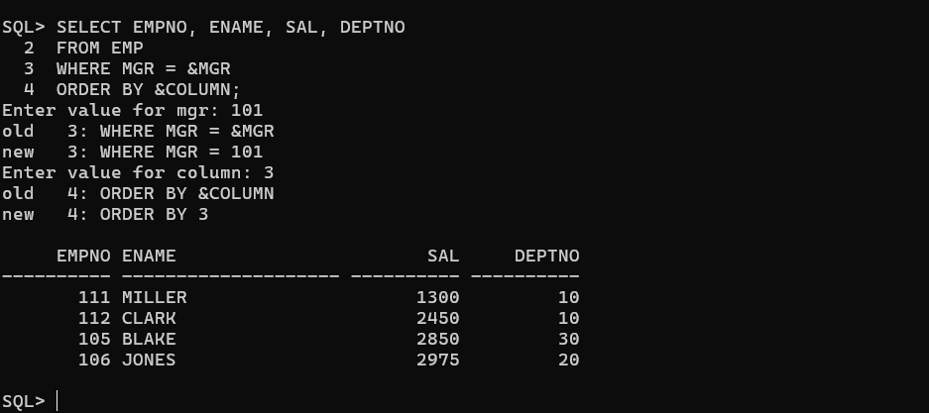

- The HR department wants to run reports based on a manager. Create a query that prompts the user for a MGR and generates the EMPNO, ENAME, SALARY, and DEPARTMENT for that manager's employees. The HR department wants the ability to sort the report on a selected column.

SELECT EMPNO, ENAME, SAL, DEPTNO
FROM EMP
WHERE MGR = &MGR
ORDER BY &COLUMN;

OutPut:-

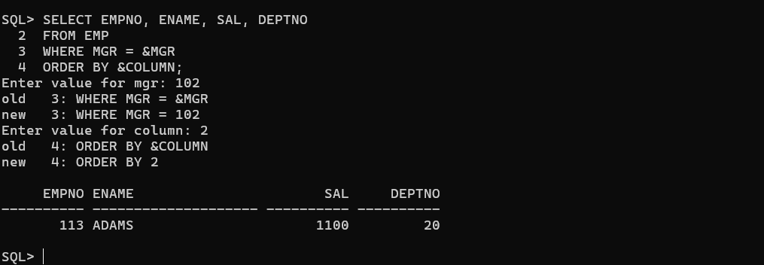

- Display all employee last names in which the third letter of the name is A.

SELECT ENAME
FROM EMP
WHERE ENAME LIKE '__A%';

Output:-

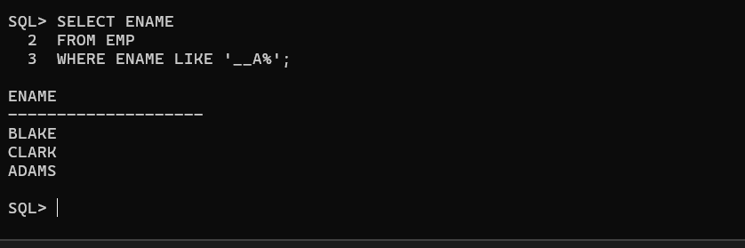

- Display the last name of all employees who have both an A and an S in their name.

SELECT ENAME
FROM EMP
WHERE ENAME LIKE '%A%'
AND ENAME LIKE '%S%';

Output:-

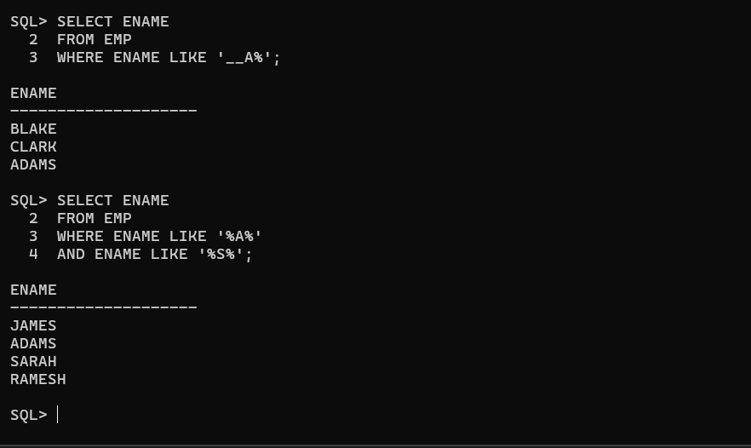

- Display the ENAME, JOB, SAL for all employees whose job is CLERK and whose salary is 800, 950, or 1300.

SELECT ENAME, JOB, SAL
FROM EMP
WHERE JOB = 'CLERK'
AND SAL IN (800, 950, 1300);

Output:-

